**Step 1: Drawing Basic Shapes With Python Turtle**

1. Create an new Repl by selecting the **“Python with Turtle”** language / environment.

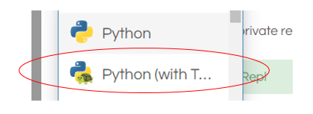

1. Begin all of your turtle programs with the following code to create a “pen”:

import turtle

myPen = turtle.Turtle()

1. Review the following chart for a list of Turtle commands.

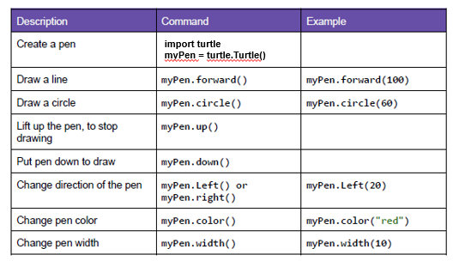

1. Use the following program to draw a red square.

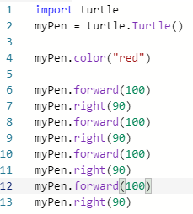

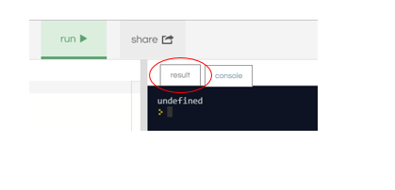

1. Switch to the “Result” window to see the square.
2. Create a program to draw any one of the shapes “b”, ”d”, or “e” shown in the figures below.   
   Provide a listing of your program code.

import turtle

myPen = turtle.Turtle()

myPen.color("aqua")

myPen.forward(100)

myPen.right(90)

myPen.forward(50)

myPen.right(90)

myPen.forward(100)

myPen.right(270)

myPen.forward(100)

myPen.right(90)

myPen.forward(50)

myPen.right(90)

myPen.forward(100)

myPen.left(90)

myPen.forward(100)

myPen.right(90)

myPen.forward(50)

myPen.right(90)

myPen.forward(100)

myPen.left(90)

myPen.forward(100)

myPen.right(90)

myPen.forward(50)

myPen.right(90)

myPen.forward(100)

1. Create a program to draw any one of the shapes “c”, or “f” shown in the figures below.   
   Provide a listing of your program code.

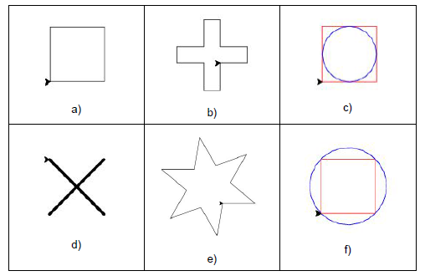

import turtle

myPen = turtle.Turtle()

myPen.color("black")

myPen.forward(100)

myPen.right(90)

myPen.forward(100)

myPen.right(90)

myPen.forward(100)

myPen.right(90)

myPen.forward(100)

myPen.right(90)

myPen.forward(50)

myPen.right(90)

myPen.up()

myPen.color("blue")

myPen.forward(50)

myPen.right(90)

myPen.forward(50)

myPen.right(270)

myPen.down()

myPen.circle(50)

**Step 2: Christmas / Winter Theme Card**

1. Use your creativity to create a card design using Turtle.
   1. The design must have multiple figures.
   2. The design must have at least two different patterns.
   3. You may repeat patterns.
   4. Provide a listing of your program code.
   5. Provide an image of your program result.

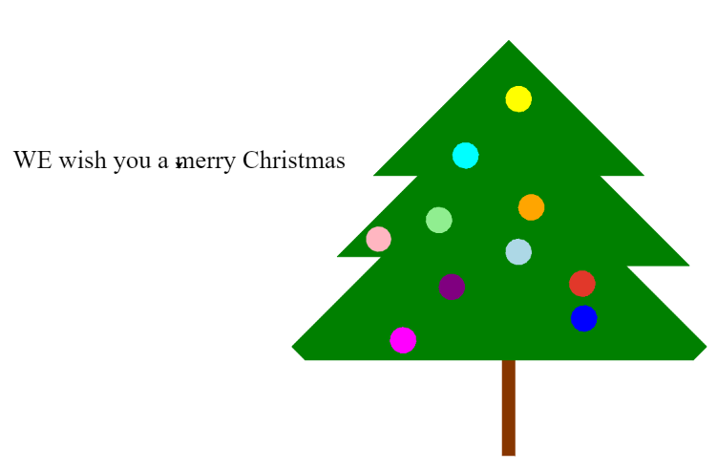

import turtle

myPen = turtle.Turtle()

myPen.speed(10)

myPen.color("#873600")

window = turtle.Screen()

window.bgcolor("#2CD5AC")

myPen.fillcolor("#873600")

myPen.begin_fill()

myPen.forward(20)

myPen.right(90)

myPen.forward(150)

myPen.right(90)

myPen.forward(20)

myPen.right(90)

myPen.forward(150)

myPen.end_fill()

myPen.fillcolor("green")

myPen.color("black")

myPen.begin_fill()

myPen.color("green")

myPen.right(90)

myPen.forward(300)

myPen.left(45)

myPen.forward(30)

myPen.left(90)

myPen.forward(180)

myPen.right(135)

myPen.forward(100)

myPen.left(135)

myPen.forward(200)

myPen.right(135)

myPen.forward(70)

myPen.left(135)

myPen.forward(300)

myPen.right(270)

myPen.forward(300)

myPen.left(135)

myPen.forward(70)

myPen.right(135)

myPen.forward(180)

myPen.left(135)

myPen.forward(70)

myPen.right(135)

myPen.forward(200)

myPen.left(90)

myPen.forward(30)

myPen.left(90)

myPen.right(45)

myPen.forward(310)

myPen.end_fill()

myPen.fillcolor("dark red")

myPen.color("#E1382A")

myPen.up()

myPen.left(90)

myPen.forward(100)

myPen.right(90)

myPen.forward(125)

myPen.begin_fill()

myPen.down()

myPen.circle(20)

myPen.end_fill()

myPen.fillcolor("light blue")

myPen.color("light blue")

myPen.up()

myPen.left(90)

myPen.forward(90)

myPen.left(90)

myPen.forward(100)

myPen.down()

myPen.begin_fill()

myPen.circle(20)

myPen.end_fill()

myPen.fillcolor("light pink")

myPen.color("light pink")

myPen.up()

myPen.forward(200)

myPen.right(90)

myPen.begin_fill()

myPen.down

myPen.circle(20)

myPen.up()

myPen.end_fill()

myPen.fillcolor("yellow")

myPen.color("yellow")

myPen.up()

myPen.forward(200)

myPen.right(90)

myPen.forward(200)

myPen.begin_fill()

myPen.down()

myPen.circle(20)

myPen.end_fill()

myPen.fillcolor("orange")

myPen.color("orange")

myPen.up()

myPen.right(90)

myPen.forward(150)

myPen.begin_fill()

myPen.down()

myPen.circle(20)

myPen.end_fill()

myPen.fillcolor("light green")

myPen.color("light green")

myPen.up()

myPen.right(90)

myPen.forward(125)

myPen.begin_fill()

myPen.down()

myPen.circle(20)

myPen.end_fill()

myPen.fillcolor("purple")

myPen.color("purple")

myPen.up()

myPen.left(90)

myPen.forward(125)

myPen.begin_fill()

myPen.down()

myPen.circle(20)

myPen.end_fill()

myPen.fillcolor("blue")

myPen.color("blue")

myPen.up()

myPen.left(90)

myPen.forward(150)

myPen.right(45)

myPen.forward(90)

myPen.begin_fill()

myPen.down()

myPen.circle(20)

myPen.end_fill()

myPen.fillcolor("magenta")

myPen.color("magenta")

myPen.up()

myPen.right(135)

myPen.forward(150)

myPen.forward(120)

myPen.begin_fill()

myPen.down()

myPen.circle(20)

myPen.end_fill()

myPen.fillcolor("cyan")

myPen.color("cyan")

myPen.up()

myPen.right(90)

myPen.forward(250)

myPen.right(90)

myPen.forward(98)

myPen.begin_fill()

myPen.down()

myPen.circle(20)

myPen.end_fill()

myPen.left(90)

myPen.up()

myPen.forward(300)

myPen.color("black")

myPen.right(90)

myPen.down()

myPen.forward(500)

myPen.right(90)

myPen.forward(950)

myPen.right(90)

myPen.forward(1300)

myPen.right(90)

myPen.forward(950)

myPen.right(90)

myPen.forward(800)

myPen.right(180)

myPen.forward(450)

myPen.up()

myPen.left(90)

myPen.forward(300)

myPen.write("WE wish you a merry Christmas and a Happy New Year", align = "center" , font=("Comic Sans", 50, "normal"))